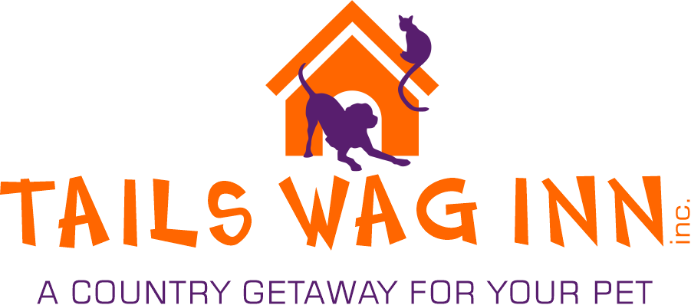
Client Registration Form
Owner Name_____________________Phone_____________________Cell_________________ Email________________________________Address___________________________________ City________________ Postal Code_____________________
Alternate Emergency Contact: Name______________________Phone:__________________
Vet Clinic: __________________________Phone: ____________________________
Please choose from one of the following and INITIAL if you are boarding your DOG.
Tails Wag Inn will not be held responsible for any injuries incurred as a result of social play.
1. My dog is social and I agree to allow them to take part in play time with others
_____(INITIAL) *Please select this ONLY if your dog is not aggressive and is able to socialize.
2. My dog is NOT social and I do not give permission for them to take part in play time _____(INITIAL)
I have read the hours of operation, as well as any holiday hours of operation and I agree to abide by and respect them. _______ (INITIAL)
If your pet should require medical attention at any time during their stay at Tails Wag Inn Inc. we will attempt to contact the owner and/or the owner’s emergency contact before proceeding. If efforts to reach the owner and/or the owner’s contact fail, Tails Wag Inn Inc. will contact the pet’s regular veterinarian. If said veterinarian is unavailable or if required, we will choose another vet clinic at our discretion.
If we must seek the services of a veterinarian for any reason the owner is responsible for all charges incurred.
The owner is responsible for any damage to the facility or other animals caused by their pet. Tails Wag Inn Inc. will not be held responsible for any items lost or damaged. Payment methods accepted include e-transfer, cash, debit, VISA and Mastercard. Sorry, no cheques.
We strongly recommend the use of flea and deworming prevention before kenneling. If your pet is found to be carrying parasites during their stay they will be brought to an available vet for treatment – the cost of which is the responsibility of the owner. We do not feed raw diets or rawhide chews. We apologize for any inconvenience. We are happy to provide a maintenance kibble for an additional fee.
The owner is responsible for ensuring all required vaccines are kept up to date. Pets without updated vaccines will not be permitted into the kennel. (Dogs: DHPP, Rabies, Kennel cough / Cats: FVRCP and Rabies.)
When guests are picked up during afternoon hours a $14 daycare charge will be applied to their invoice per kennel. Please check our hours of operation before picking up/dropping off. They are available on our website www.tailswaginn.ca, on Facebook or ask at the front desk.
A cancellation fee of $27 + tax per kennel for dog boarding, $20 + tax per kennel for daycare, $18 + tax per kennel for cats will be charged for all cancellations made without 48 hours notice. This fee is increased to $40+ tax per kennel for holiday booking cancellations. Early pick up without 24 hours notice is subject to a $27 +tax fee per kennel for dog boarding, $18 +tax/kennel for cats and $20 + tax/kennel for daycare.
I have read and understand the terms above, which will apply anytime my pet is under the care of Tails Wag Inn Inc.
Date: _________________ Owner Name: __________________________
Owner Signature: __________________________

